**Name : abdallah samir abdel-rahman ali**

**B.N: 491**

**Date : 31-5-2020**

**Topic:** **artificial intelligence**

**Github link :**

**Github page :**

**Application brief :**

Artificial intelligence is one of the types of modern science that has spread widely in recent times, so it has entered into many areas of industry and research, led by robots and smart services for governments and companies.

Artificial intelligence is defined as one of the branches of computer science, and that is the behavior and characteristics that different computer programs rely on, and is in line with human mental capabilities in various works. Among the most important of these capabilities is the ability of the machine to teach and make the right decisions.

**Screeshots :**

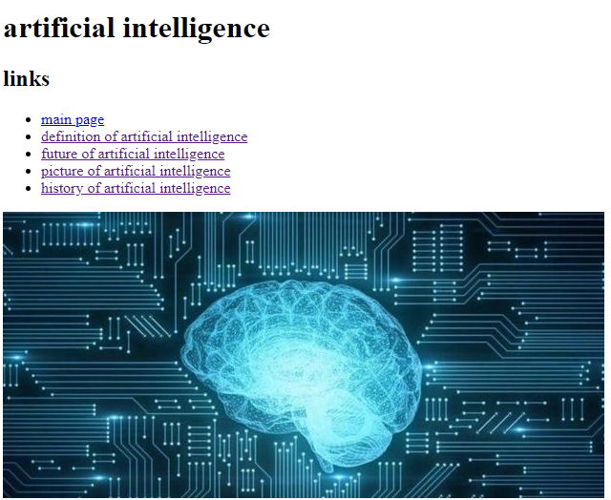

**(1)**

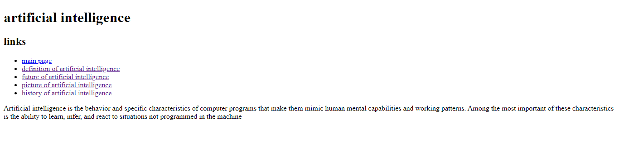**(2)**

**Source code:**

